FREE Community Meals—South King County

Monday Noon South Sound Dream Centers
1336 S 336TH, Federal Way

4:30 p.m. Community Supper—First United Methodist Church
100 N ST SE, Auburn 253-833-8925

Steel Lake Presbyterian Church
1829 S 308TH ST, Federal Way 253-661-0505

5 p.m. Kent Lutheran Church
336 2ND AVE S, Kent 253-852-2057

Federal Way Calvary Lutheran Church
2415 S 320TH, Federal Way (by the mall) 253-839-0344

Tuesday 11:30 a.m. Auburn Dream Centers (hot brunch, sack brunch to go)
Grace Community parking lot
1420 AUBURN WAY S, Auburn 253-288-1806

5 p.m. Federal Way Calvary Lutheran Church
2415 S 320TH, Federal Way (by the mall) 253-839-0344

Wednesday 11:30 a.m. Lunch in the Park—Les Gove Park
1005 12TH ST SE, Auburn

4:30 p.m. Kent Seventh-Day Adventist Church
25213 116TH ST SE, Kent 253-852-3883

5 p.m. His Ministry
240 AUBURN WAY S #1-B, Auburn 253-315-9570

5:30 p.m. Northwest Family Church (also have a bank of clothing and household items)
3535 AUBURN WAY S, Auburn 253-833-8252

Thursday 5 p.m. Federal Way Calvary Lutheran Church
2415 S 320TH, Federal Way (by the mall) 253-839-0344

5:30 p.m. Korean Presbyterian (White River Presbyterian) Church
526 12TH ST SE, Auburn 253-833-2990

Friday 5 p.m. Community Dinner—Zion Lutheran Church
Auburn Way South at M Street Southeast, Auburn

Saturday 11 a.m. Auburn Dream Centers (hot brunch, sack brunch to go)
Grace Community parking lot
1420 AUBURN WAY S, Auburn 253-288-1806

11:30 a.m. Fourth Saturday of the month--call ahead, sometimes rescheduled to third Saturday of month
Calvary Chapel South
317 4TH AVE S, Kent 253-852-7030

1:30 p.m. Church of the Good Shepherd
345 S 312TH ST, Federal Way 253-839-6100

4:30 p.m. Kent Seventh-Day Adventist Church
25213 116TH ST SE, Kent 253-852-3883

Sunday 2 p.m. Messiah Lutheran Church
410 H ST NE, Auburn 253-833-5280

Motels, hotels, and some 7-11/convenience stores will allow polite requestors, limited use of a microwave.
Polite requestors also can get hot water at most McDonald’s locations.

Auburn Food Bank – Afternoon/evening food bank the second Wednesday of the month
Need proof of address and photo ID
Monday, Tuesday, Thursday, and Friday, 9 a.m. to 1 p.m.
Second Wednesday of the month, 4:30 to 6 p.m.
930 18TH ST NE, Auburn 253-833-8925

New Hope Food Bank – The Pacific-Algona Food Pantry serves Pacific and Algona residents
Pantry is open Tuesdays, 11 a.m. to 2 p.m.
603 3RD AVE SE, Pacific 253-351-0450

St. Matthew Episcopal Church – Has a small food pantry and limited school supplies
Pantry is open Monday through Thursday, 10 a.m. to 1:30 p.m.
123 L ST NE, Auburn 253-833-0890

St. Vincent de Paul – Has a small food pantry
Serves families with proof of address in the Auburn School District
Monday through Thursday, 9:30 to 11:30 a.m. or 1:30 to 3 p.m.
Friday, 9:30 to 11 a.m.
717 AUBURN WAY N, Auburn

Muckleshoot Food Bank – North of Muckleshoot Tribal School
Proof of address and picture ID required
Monday, 2 to 4:30 pm.
Wednesday and Friday, 10 a.m. to noon – or – 1 to 3 p.m.
39015 172ND AVE SE, Auburn 253-833-8541

Kent Food Bank and Emergency Services
Proof of current address
Clothing Bank - Monday, Tuesday, Wednesday, and Friday, 10 a.m. to noon
Food Bank – Monday, Tuesday, Wednesday, and Friday, 10 a.m. to 2 p.m.
Evening Food Bank – Second Wednesday of the month, 5 to 6 p.m.
515 W HARRISON ST #107, Kent 253-520-3550

Enumclaw Kiwanis Food Bank
Current utility bill and picture ID
Monday through Wednesday, 9 to 11 a.m.
1350 COLE ST, Enumclaw 360-825-6188

Federal Way Food Bank/Multi-Service Center
Clothing Bank, Monday, Wednesday, and Friday, 11 a.m. to 1 p.m.
Proof of address, Social Security card (for first visit, if available)
Monday, Wednesday, and Friday, 10 a.m. to 2 p.m.
1200 S 336TH ST, Federal Way 253-838-6810

Auburn Youth Resources (Street Outreach serves youth in crisis) 1-888-841-2748 (253-939-2202)
Sara: 253-740-7189 – or – Alo: 253-740-7188 – or – Maira G.: 253-326-6400
Street Outreach—Tim: 253-350-0836

Cold Weather Shelter (During cold nights, 32° and below, a shelter will open. Check the City of Auburn Emergency website or call the Auburn Food Bank for location and hours.) 253-833-8925

Crisis Clinic www.crisisclinic.org (24-Hour Crisis Line) 1-866-4CRISIS (206-461-3222)

Teen Link (evenings, 6 to 10 p.m.) 1-866-TEENLINK (206-461-4922)

TeenClinic.com (a regular doctor’s office)
901 AUBURN WAY N, Auburn 253-833-8352
33431 13TH PL S, Federal Way 253-838-5140

South King County Multi-Service Center – Emergency food and other social services
1200 S 336TH, Federal Way 253-838-6810

WIC (Women, Infant, and Children’s Supplemental Food Program) 206-296-4786

Police – Fire – Medical Emergency Line (24-Hour, Nation-wide Line) 9 - 1 - 1
2-1-1 Community Information Line 2 - 1 - 1 or 1-800-621-4636 or 206-461-3200

Crisis Line (24-Hour Line) www.crisisclinic.org 1-866-4CRISIS (206-461-3222)
National Hopeline Network (24-Hour Line) 1-800-SUICIDE

Alcohol & Drug (24-Hour Help Line) www.adhl.org 1-800-562-1240
Teen Line www.theteenline.org 1-877-345-8336
Alateen & Alnon www.seattle-al-anon.org 206-625-0000
Alcoholics Anonymous www.seattleaa.org 206-587-2838
Narcotics Anonymous www.seattlena.org 206-790-8888

Open Adoption & Family Services www.openadopt.org 206-782-0442
Planned Parenthood www.ppww.org 1-800-230-PLAN

Auburn Teen Clinic 253-833-8352
Teen Choice Medical Center 253-735-TEEN
Country Doctor Free Clinic for Homeless Youth www.countrydoctor.org (ages 12-23), Seattle
Consulting Nurse Line Children’s Hospital 206-987-2500
Swedish Medical Center 206-215-2100
King County Sexual Assault Resource Center (24-Hour Crisis Line) www.kcsarc.org 1-888-998-6423
Pierce County Health Information Line 253-572-4357

Childhelp USA – National Child Abuse Hotline 1-800-422-4453
Homelessness & Runaways (King County) 2 - 1 - 1 or 1-800-621-4636
Greyhound Buslines – Operation Home Free 1-800-RUNAWAY
Offers free bus ride home for teens registered with National Runaway Switchboard 1-800-621-4000
Friends of Youth Emergency Shelter (24-Hour Line) 206-236-5437
YWCA Emergency Shelter www.ywcaworks.org 206-461-4882

DAWN (Domestic Abuse Women’s Network) South King County www.dawnonline.org 1-866-286-3296
Washington State Domestic Violence Hotline (24-Hour Line) 1-800-562-6025
Child Protective Services (24-Hour Line) www.dshs.wa.gov 1-866-363-4276
King County Superior Court (juvenile) 206-205-9500

Northwest Network of Bisexual, Trans, Lesbian & Gay Survivors of Abuse www.nwnetwork.org 206-568-7777
Parents, Families, & Friends of Lesbians and Gays (PFLAG) www.seattlecounseling.org 206-323-1768
The Trevor Project www.thetrevorproject.org 1-866-4UTREVOR

Eating Disorders Anonymous www.edaseattle.com
Eating Disorders Northwest (ages 17 and older) www.ednw.wetpaint.com
Overeaters Anonymous www.seattleoa.org 206-264-5045

AmeriCorps National Service www.americorps.gov 1-800-942-2677
Center for Career Alternatives www.ccawa.org 206-322-9080
Job Corps www.jobcorps.dol.gov 206-622-6593
YouthSource 206-205-3510

American Red Cross www.seattleredcross.org 206-323-2345
Arts Corps www.artscorps.org 206-722-5440
Big Brothers/Big Sisters www.bbbsps.org 206-763-9060
Boys and Girls Clubs of King County www.positiveplace.org 206-461-8550
Peace for the Streets by Kids from the Streets www.psks.org 206-726-8500
Powerful Voices www.powerfulvoices.org 206-860-1026

free meal & other resources 9-2015 (cc)

http://family.auburn.wa-k12.net

Parents/guardians may apply for free or reduced-price school meals through Skyward Family Access (linked through the Auburn School District website, www.auburn.wednet.edu). Go to the Child Nutrition—School Meals department page and select “Apply for Meals” button or enter this address (http://family.auburn.wa-k12.net) directly into your browser bar.

For the first month of each school year, students who finished the school year in the Auburn School District may begin the year with their end-of-year meal eligibility provided a Direct Certification match or application has not overwritten that eligibility. This courtesy allows parents/guardians time to apply for current-year meal eligibility. The courtesy, carry-over eligibility lasts only the first month of school or until a new application is processed to overwrite the old eligibility.

Online applications are now done through Skyward Family Access*. You will need to have your Family Access login and password in order to access the online application. If you have forgotten, or not yet received, your Skyward Family Access login and password, contact office staff at the school your child attends (child nutrition staff does distribute, nor manage Family Access login and/or password information). If you prefer a paper application, you can pick one up in the main office at any Auburn School District school.

Children who qualify for reduced-price meals, as well as students who qualify for free meals, will be served breakfast at no cost. If a household qualifies for reduced-price meals, students in grades 4 through 12 will be charged 40¢ for lunch. Students in grades K through 3, who qualify for reduced meals, will also be served lunch at no cost (though their eligibility is reduced).

A letter confirming meal status will be mailed after your application has been processed (allow a week to ten days for your application to be processed; however, processing typically happens in three days or less). Until you have confirmation of your status, please plan to send money with your child to pay for a meal, or pack meals for your child to take to school.

Student eligibility and meal account balances can also be viewed through Skyward Family Access.

The person completing the application must be an adult household member (actually living in the home) in Household/Family 1, the student’s primary residence.

All persons living in the household and the gross income of those people (if they have income) must be reported.

- Students currently attending in the Auburn School District are reported in section one.
- Other household members are reported in section two.

In completing the application, be sure the name of the person completing the application is included as a household member (in section two) and that the name as it is enter it in section two (where you report gross income) is an identical match (including punctuation) to where it is entered in section four.

- If it is not an identical match, the program is set to understand the different names as different people and it will throw off the count of household members you report.

When the application is complete (free of errors and all information is correctly entered) you will need to scroll to the top of the last page to press the “Submit” button.

*The screen views that follow are designed to help you through the online application process.
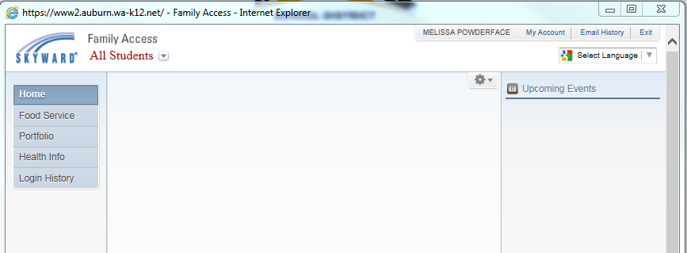
Parent/Guardian Name
IF you have more than one student currently attending in the Auburn School District, click the drop-down arrow/triangle (to the right of “All Students”) and choose the name of one of your students.

If you have only one student currently attending in the district, that student’s name should appear here (instead of the words “All Students”).
You may choose to view Family Access and the application for free or
reduced-price meals in another language by clicking here.

\

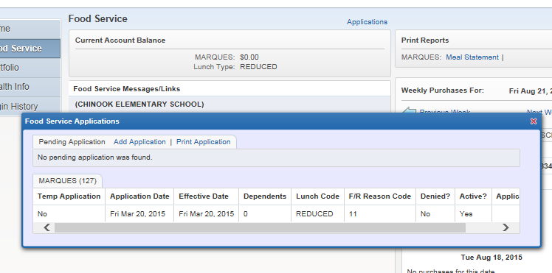
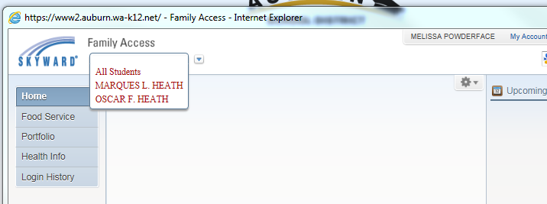
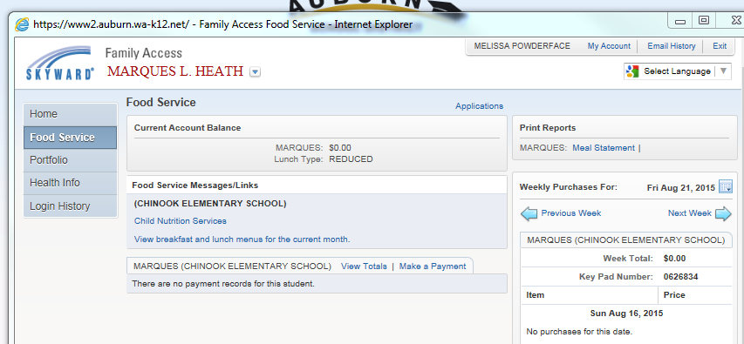
Student first name & school/entity number
Student first name
School name
Student first name
To fill out an application, choose “Add Application” and you will be taken to the application.

The first few pages of the application are information for you.
Parent/Guardian Name
Parent/Guardian Name
Parent/Guardian Name
First and Last name (one student)
First and Last name (the other)
First and Last name of the student you dropped to above
Student first name
Student first name
School name
Student first name (school name)School name
Student first name (school name) School name
Student ID#
Select “Food Service” once you have a student name on the top of the screen.
Click “Applications.”

Student first name & school/entity number
Student first name
School name
Student first name
To fill out an application, choose “Add Application” and you will be taken to the application.

The first few pages of the application are information for you.
Student first name & school/entity number
Student first name
School name
Student first name
To fill out an application, choose “Add Application” and you will be taken to the application.

The first few pages of the application are information for you.
Student first name & school/entity number
Student first name
School name
Student first name
To fill out an application, choose “Add Application” and you will be taken to the application.

The first few pages of the application are information for you.
Student first name & school/entity number
Student first name
School name
Student first name
To fill out an application, choose “Add Application” and you will be taken to the application.

The first few pages of the application are information for you.

http://access.wa.gov/employment/unemploymentinfo.aspx

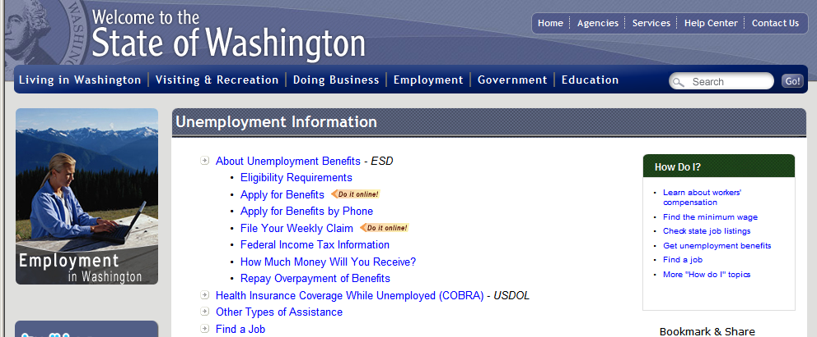

https://fortress.wa.gov/dshs/f2esaapps/esaosa/

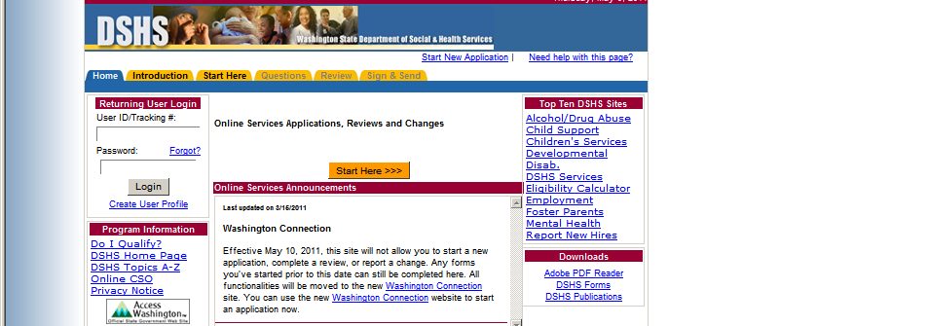

http://www.kingcounty.gov/courts/detention/resource_guide/emergency.aspx

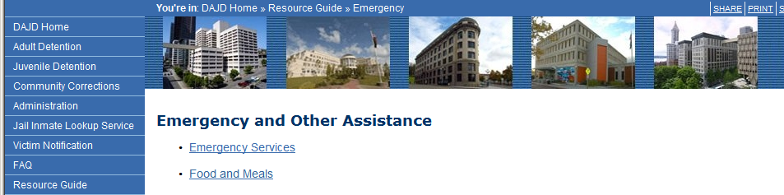
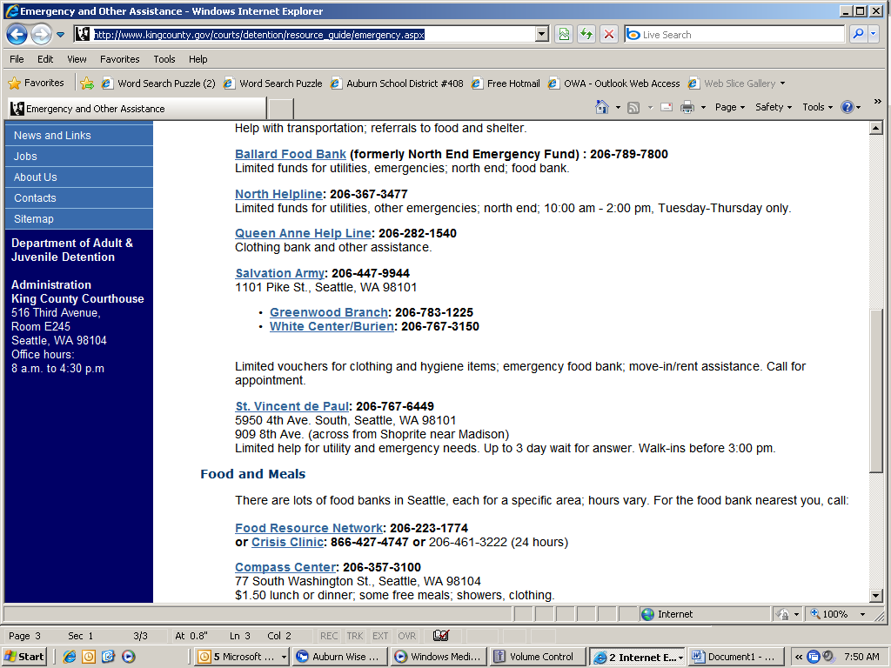
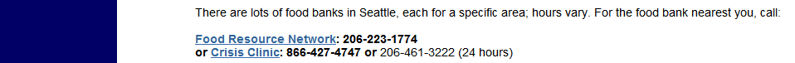

http://www.dshs.wa.gov/onlinecso/Food_Assistance_Program.shtml

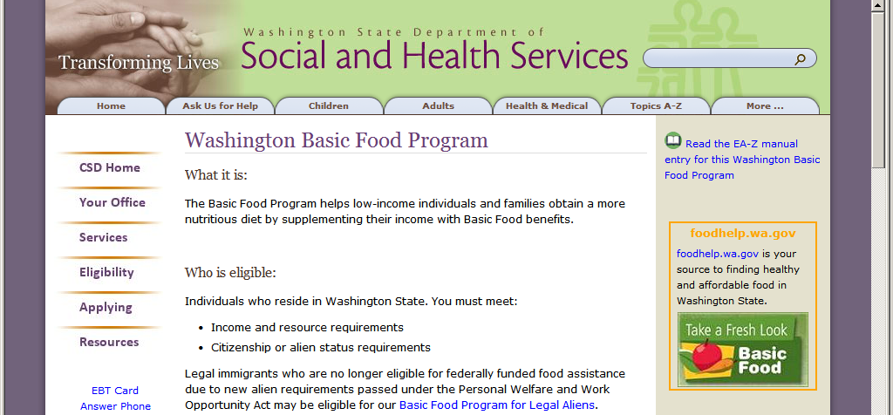
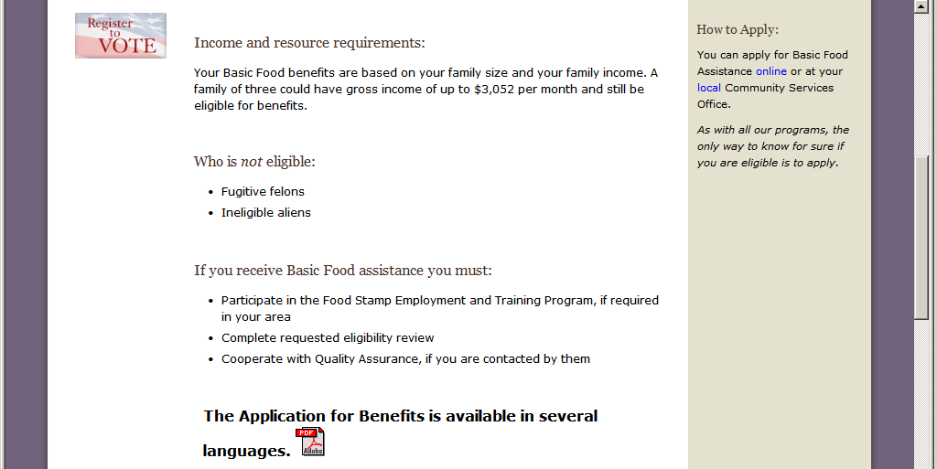

Auburn CSO # 72  Counties Served: King  1-877-501-2233  TTY 1-800-209-5446  What is the Physical Address of the office?  810 28TH ST NE, Auburn  Where should you send client documents?  DSHS CSD - Customer Service Center  PO BOX 11699  TACOMA WA 98411-6699  Fax Number (toll-free) 1-888-338-7410 | King South (Kent) CSO # 43  Counties Served: King  1-877-501-2233  TTY 1-800-209-5446  What is the Physical Address of the office?  1313 W MEEKER ST #100, Kent  Where should you send client documents?  DSHS CSD - Customer Service Center  PO BOX 11699  TACOMA WA 98411-6699  Fax Number (toll-free) 1-888-338-7410

http://foodstamp-application.org/apply/?t202kw=www.fns.usda.gov/fsp/outreach/map.htm

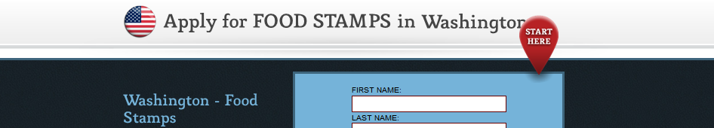
http://www.homelessshelterdirectory.org/cgi-bin/id/cityfoodbanks.cgi?city=Auburn&state=WA

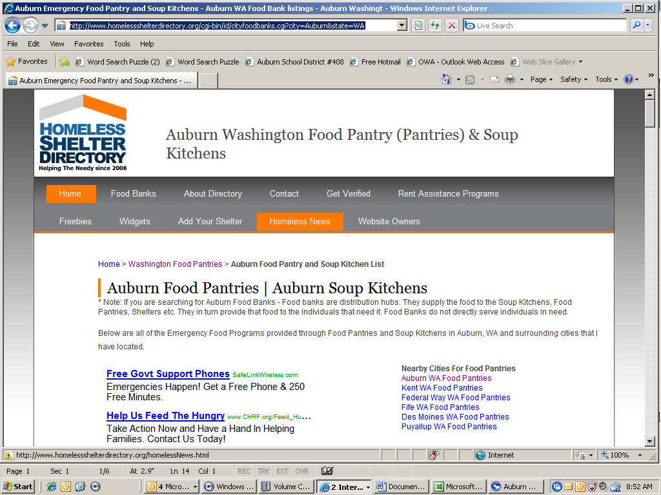

http://www.endhomelessnesswa.org/resources/counties/18/

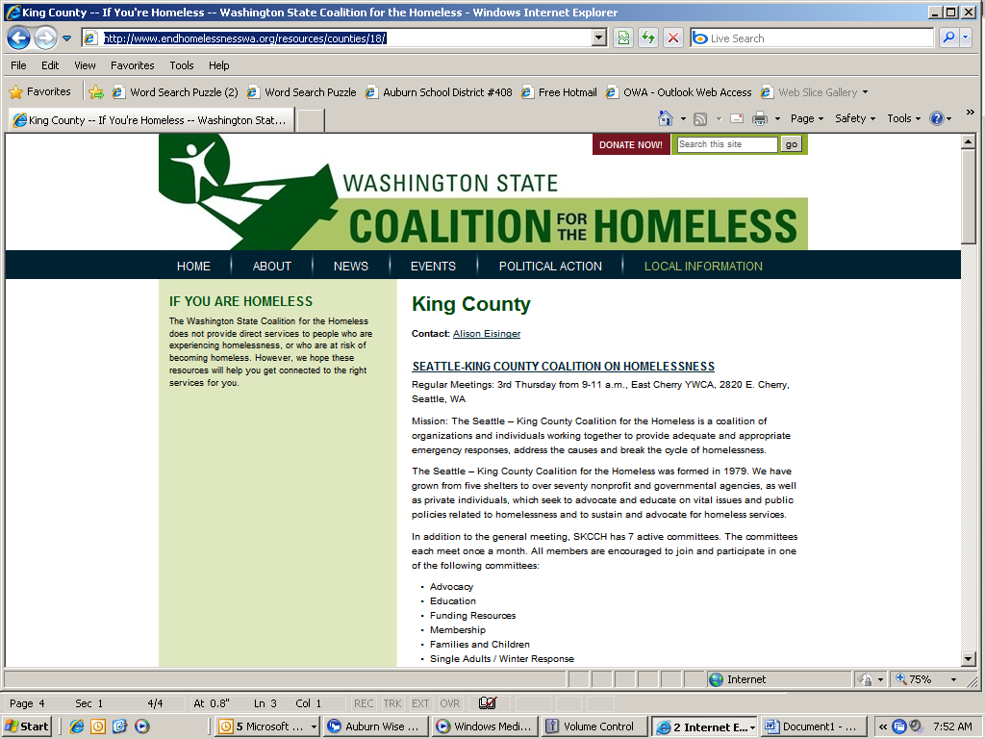

http://insurance.healthcare.com



This information is NOT compiled or sponsored by the Auburn School District and the district assumes no responsibility for the accuracy of the information. In consideration for the privilege to distribute these materials, the school district shall be held harmless from any cause of action, claim, or petition filed in any court or administrative tribunal arising out of the distribution of these materials, including all costs, attorney’s fees, and judgments or awards.

